--------------------------------------------- Unix and Shell Scripting ------------------------------------------------------------

**Systemd?**

**soflink/hardlink**

**Namespaces in Linux?**

**How to fetch top5 processes?**

**$n**

**N/w slow issue?**

**Use of expr ' ?**

**How to patch Linux machine**

**How to fetch thread dump from a java process?**

**How to check agents in Linux?**

**How to call particular function in bash?**

**Is there any method to replace string other than SED command?**

**Provisioning using shell scripting?**

**How to convert all files(text/what ever may be) into (extention).xml files?**

**how to run job in background?**

**if you want to create a ext4 file system, what command we use?**

**what is the difference b/w ext3 and ext4?**

**if the file system is corupted how your restore it?For example: i monuted volume in /mnt, my /mnt is corrupted how you recover it?do you know command?**

**Do you know SAR command?**

**SAR command in Linux to monitor system performance**

**Do you know network level commands?**

**https://geekflare.com/linux-networking-commands/**

**Diff b/w shell scripting and python scripting?**

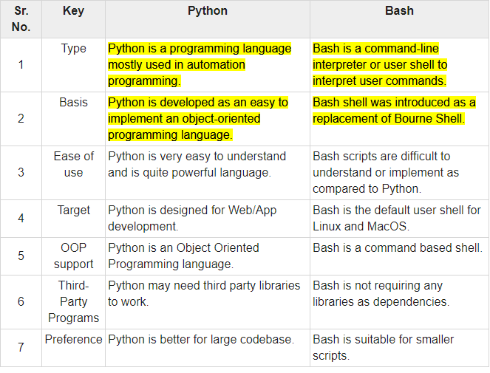

**How to expose port in Linux?**

**apt install net-tools ----**to install netstat if in case not present

Use command **netstat -tulpn** to open ports.

Another option is to run **ss -tulpn** to open ports on modern Linux distros.

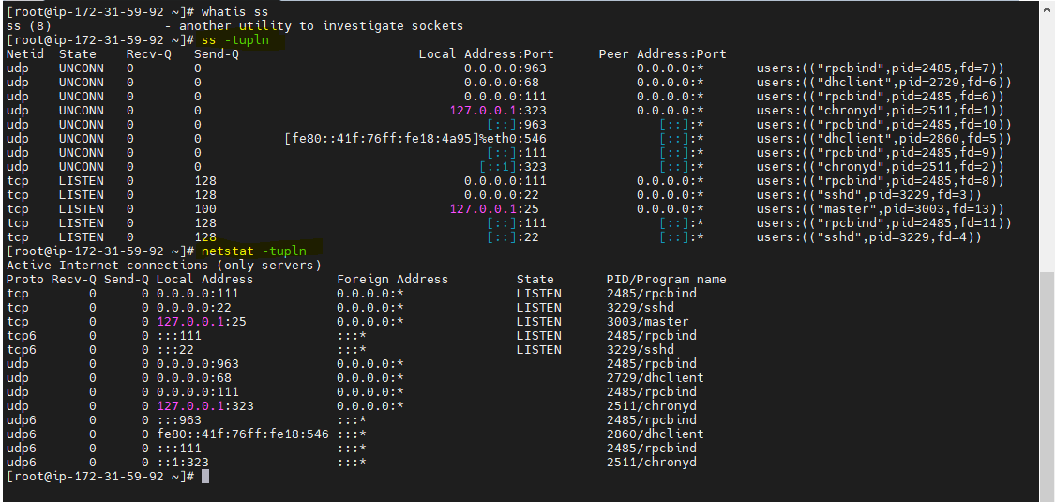

**Does touch create duplicate files?**

Yes touch command handles duplicate file creation. We need to use the “-c” option in the touch command to avoid creating the duplicate in the same working directory.

**Flags used for TCP connection establishment(3 way handshake)**

TCP uses a three-way handshake to establish a reliable connection. The connection is full duplex, and both sides synchronize (SYN) and acknowledge (ACK) each other. The exchange of these four flags is performed in three steps—**SYN, SYN-ACK, and ACK**—as shown in Figure

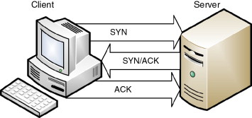

**How to discover how many files are opened by a process?**

lsof- lsof meaning **'LiSt Open Files**' is used to find out which files are opened by which process

**Monitoring utilities in Linux?**

1. **top** – Process activity monitoring command ,top command display Linux processes.

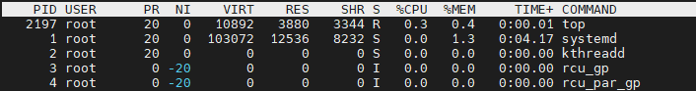

1. **vmstat** – Virtual memory statistics.The vmstat command reports information about processes, memory, paging, block IO, traps, and cpu activity.

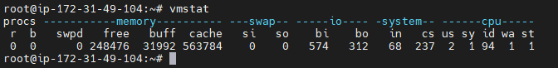

1. **uptime** – Tell how long the Linux system has been running



1. **ps** – Displays the Linux processes

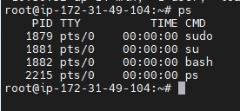

1. **free** – Show Linux server memory usage

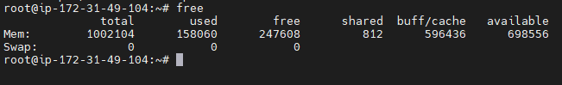

1. **lsof**- The Linux lsof command lists information about files that are open by processes running on the system
2. **iostat** – Monitor Linux average CPU load and disk activity

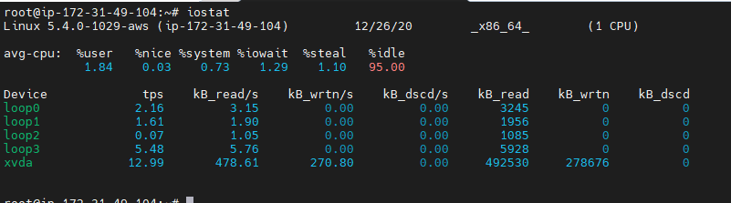

1. **mpstat** – Monitor multiprocessor usage on Linux

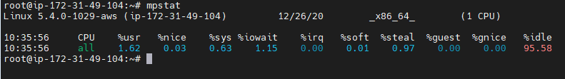

1. **netstat** – Linux network and statistics monitoring tool

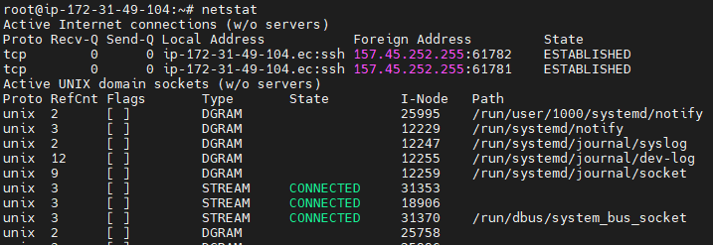

1. htop – interactive process viewer

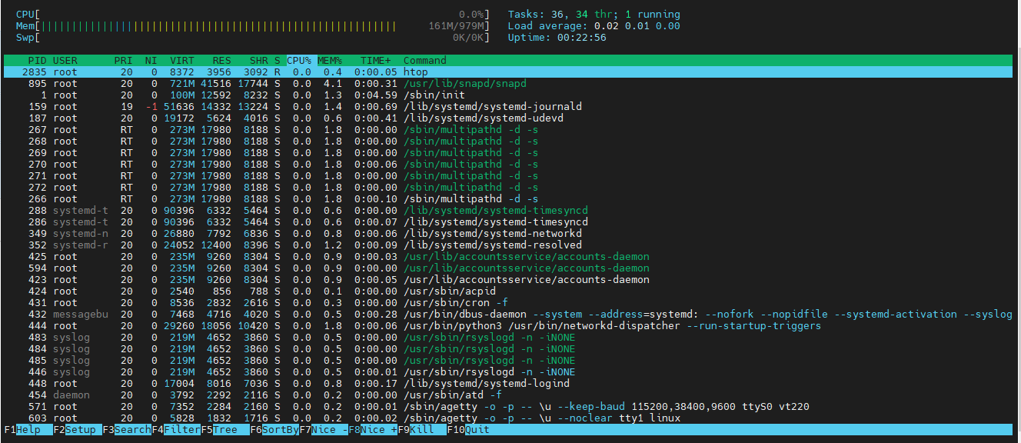

1. atop – Advanced Linux system & process monitor
2. **nethogs**- Find out PIDs that using most bandwidth on Linux
3. **sar** – Monitor, collect and report Linux system activity
4. tcpdump – Detailed network traffic analysis
5. iotop – Linux I/O monitor

**use of tee command in linux?**

tee command reads the standard input and writes it to both the standard output and one or more files..  It basically breaks the output of a program so that it can be both displayed and saved in a file..

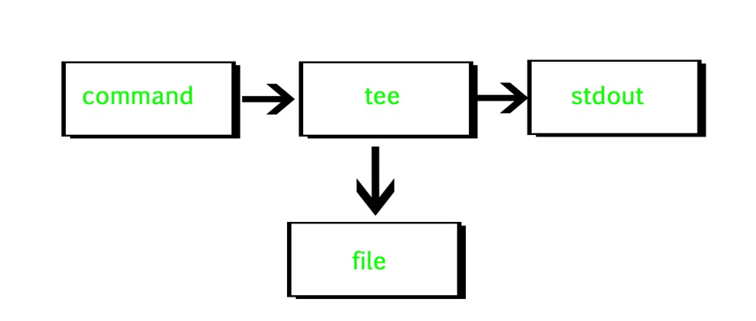

**Ex :::::: sort $filename | uniq | tee sorted.txt**

**Use of eval command?**

*eval* is a built-in Linux command which is used to execute arguments as a shell command.

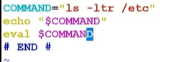

**What is chown cmd?**

The chown command allows you to change the **user and/or group ownership** of a given file, directory

**What is usermod cmd?**

To change file and directory permissions

**How to check file name under subdirectory?**(recursive)

-R Recursively lists subdirectories

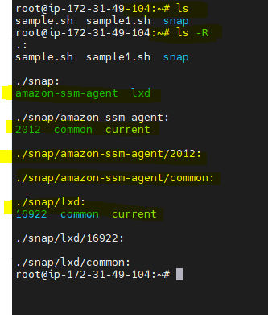

Y**ou created a user with sudo permissions, you want to use that user in script like for starting apache**

**services but don’t want ask password every time. what you will do?**

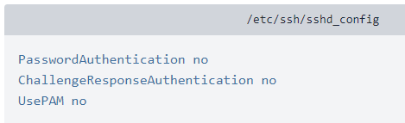

**How to fetch and send output of shell scritpting?**

**(**To use **bash redirection**, you run a command, specify the > or >> operator)

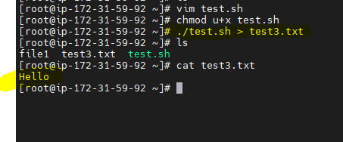

**Command to check services in linux?**

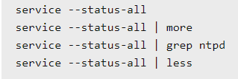

Systemctl status servicename

**How to check hidden files?**

ls -R  
ls -R /tmp/dir1

**Diff b/w break and continue?**

**Break** statement mainly used to terminate the enclosing loop such as while, do-while, for or switch statement wherever break is declared. ...**Continue** statement mainly skip the rest of loop wherever continue is declared and execute the next iteration.

**How to know the process name from process ID?**

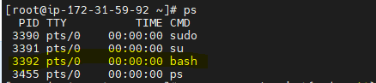

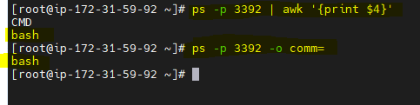

**How to check kernetl version? –**uname –r

**What is Dmesg command?**

dmesg command also called as “driver message” or “display message” is used to examine the kernel ring buffer and print the message buffer of kernel

**How to copy hidenfiles?**

Scp –r

**Can we lock files in linux ?**

Locking files with flock. One common way to lock a file on a Linux system is flock . The flock command can be used from the command line or within a shell script to obtain a lock on a file and will create the lock file if it doesn't already exist, assuming the user has the appropriate permissions.

- manage locks from shell scripts

**How to get present working folder?**

Pwd

IF you want to get the specific folder/directory use ---- basename “$PWD”

**How to copy files from local windows machine to cloud based Linux machine?**

Ans ::: **pscp** (from windows powershell) –vice versa is possible

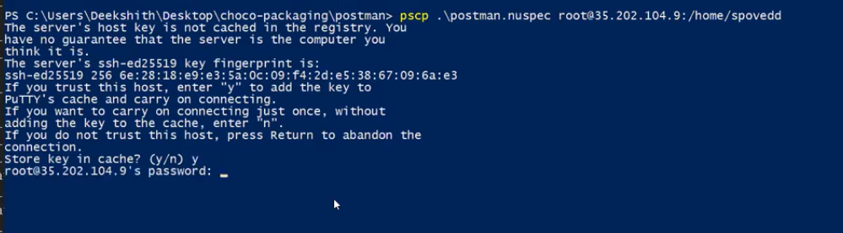

**A shell script named test.sh can accept 4 parameters i.e, a,b,c,d. the parameters wont be supplied in order always and number of parameters might also vary( only 2 parameters user might supply sometimes), how to identify position of letter c ?**

i=0:

|  |
| --- |
|  |
|  | for p in "$@" ; do |
|  | i=$((i+1)) |
|  | if [ $p = "c" ]; then |
|  | echo "User supllied C has a parameter, in $i position" |
|  | fi |
|  | done |

0 1 2 3 4

root@ip-172-31-49-104:~# **bash -x sample1.sh e t s c**

+ i=0 --------------initially its 0

+ for p in "$@"

+ i=1

+ '[' e = c ']'

+ for p in "$@"

+ i=2

+ '[' t = c ']'

+ for p in "$@"

+ i=3

+ '[' s = c ']'

+ for p in "$@"

+ i=4

**+ '[' c = c ']'**

+ echo 'User supplied C has a parameter ,in 4 position'

**User supplied C has a parameter ,in 4 position**

**Lets say if I want to execute the cmd based on the last command output ,say if it is success then only I need to execute the command ? how can I achieve this ?**

Using exit cmd

Echo $? ===0 success (other than 0 ,then failure)

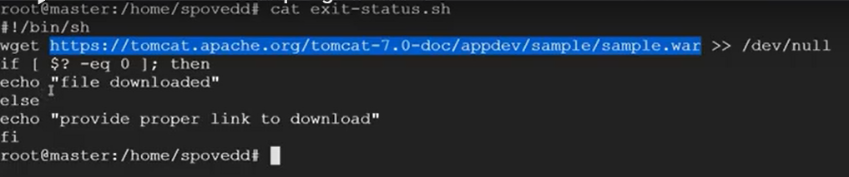

#!/bin/bash

wget <https://------------------------------->

If [ $? –eq 0 ]; then

echo “file downloaded”

else

echo “provide a proper link to download”

fi

**Lets say we’ve shell script named magic.sh ,when we execute. It should give “This is from magic.sh” as a output.If Accidentally someone changed the name from magic.sh to magic-changed.sh then it should show “This is from magic-changed.sh” as output.**

#!/bin/bash

echo "This is from "$0" "

Output :

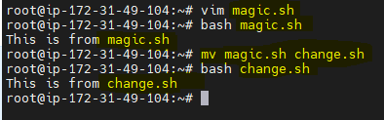

**Let’s say I have many application properties and that I need to use it in my shell script ,which is the better way to achieve this ?**

Config file===

nam="Mark"

sur="Brown"

#!/bin/bash

source config

echo "Name=$nam"

echo "Surname=$sur"

The **source command** can be **used** to load any functions file into the current shell script or a **command** prompt.

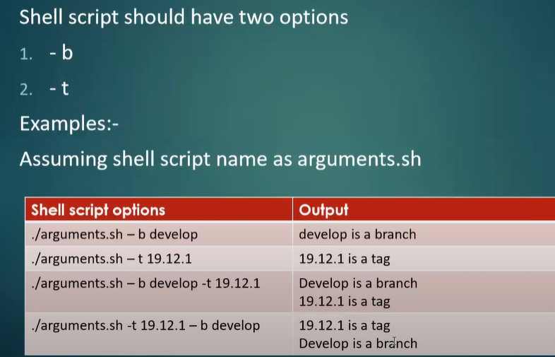

while

[ -n "$1" ]

do

case "$1" in

-b)

echo "$2 is a branch"

shift

;;

-t)

echo "$2 is a tag"

shift

;;

*)

echo "option $1 not recognized"

exit 1

;;

esac

shift

done

**If want to display present working folder?**

Basename “pwd”

**I need to have a shell script whenever I execute the script that should monitor my application log folder,if the folder contains more than 10files then I should print “folder has more than 10files” and also delete extra files based on modification date else script should print ”folder has less than or equal to 10files”**

#!/bin/bash

folder_path="/home/deekshithsn1/application_logs"

cd $folder_path

count_of_files=$( ls -1 | wc -l )

if [ $count_of_files -gt 10 ]

then

echo "folder has more than 10 files"

ls -lt | tail -n +11 | xargs rm -f

else

echo "folder has less than or equal to 10 files"

fi

**A script which accepts one parameter it can be filename or folder,if it is folder delete it else print “This is a file”**

read input

|  |  |
| --- | --- |
|  | echo "entered value is $input" |
|  | if [ -d $input ] ; then |
|  | rm -rf $input |
|  | elif [ -f $input ] ; then |
|  | echo "its file" |
|  | else |
|  | echo "file or directory not found" |
|  | fi  **How to check whether particular port id already in use or not?**  **netstat –tupln**  t---tcp  u—udp  pl-protocal  n—numeric  **or**  **ss –tupln**  **Logic for checking whether supplied string for a script is palindrome or not? What are all the commands you will use?**  read palindrome   |  |  | | --- | --- | |  | reverse=$( echo $palindrome | rev ) | |  | if [ $palindrome = $reverse ]; then | |  | echo "its palindrome" | |  | else | |  | echo "its not palindrome"  fi | |  | Or  #!/bin/bash  palindrome=$1  rev1=$( echo $palindrome | rev)  if [ $rev1 = $palindrome ]  then  echo "Entered string is palindrome"  else  echo "Entered string is not a palindrome"  fi |   **Command to get number of lines in a file?**  Cat filename | wc –l (l –line ,c-characters,w—words)  **In a file I have ip addresses, I want to list unique ip addresses with number of times its present in file?**  **$ cat file.txt**  27.33.65.2  27.33.65.2  58.161.137.7  121.50.198.5  184.173.187.1  184.173.187.1  184.173.187.1  **$ uniq -c logfile.txt | awk '{print $2": "$1}'**  27.33.65.2: 2  58.161.137.7: 1  121.50.198.5: 1  184.173.187.1: 3  **What is exit status in unix?**  Every Linux or Unix command executed by the shell script or user has an exit status. Exit status is an integer number. 0 exit status means the command was successful without any errors. A non-zero (1-255 values) exit status means command was a failure.  **Command to find empty files in a given directory?**  find . –type d –empty  Linux / Unix: Find and Delete All Empty Directories & Files - nixCraft |
|  |  |

**How to schedule a shell script in unix machine?**

Use crontab

**How to identify ip addresses in logfile and count of IP addresses in logfile?**

 uniq -c logfile.txt | awk '{print $2": "$1}'

**How to run shellscript in background?**

./script name &

./script name (ctrl +z) + bg

**What is swap memory?**

Swap space in Linux is used when the amount of physical memory (RAM) is full. If the system needs more memory resources and the RAM is full, inactive pages in memory are moved to the swap space. While swap space can help machines with a small amount of RAM, it should not be considered a replacement for more RAM

**I have a mount file how to check mount file list?**

The **findmnt** command is a simple command-line utility used to display a list of currently mounted file systems.

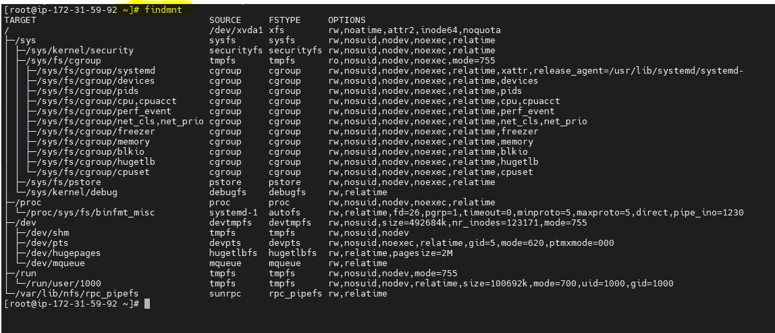

**Can you write a script for to get current date, time, user name, current working directory?**

#!/bin/bash

echo "Current Date:"  
date  
echo "Username:"  
whoami  
echo "Current direcotry:"  
pwd

**Output:**  
Current Date:  
Wed Dec 27 17:53:27 UTC 2017  
Username:  
root  
Current direcotry:  
/home

**script for merging content of two files?**

[root@ip-172-31-59-92 ~]# **whatis paste**

paste (1) - merge lines of files

paste (1p) - merge corresponding or subsequent lines of files

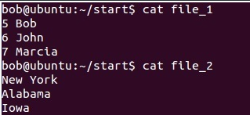

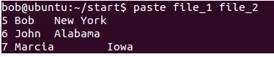

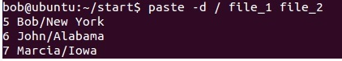

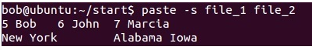

**convert a string into reverse order?**

rev (1) - reverse lines characterwise

[root@ip-172-31-59-92 ~]# cat > test1.sh

tuejfeflk

[root@ip-172-31-59-92 ~]# cat test1.sh | rev

klfefjeut

[root@ip-172-31-59-92 ~]#

**How to declare a variable in shell script?**

[root@ip-172-31-59-92 ~]# **name=lokesh**

[root@ip-172-31-59-92 ~]# echo $name

Lokesh

**What is awk command in linux?**

Awk is a scripting language used for manipulating data and generating reports.

**Use of exec command?**

exec command in Linux is used to execute a command from the bash itself. This command does not create a new process it just replaces the bash with the command to be executed

**How we can check a mount file?**

**df**

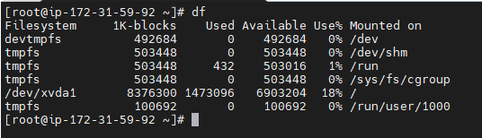

**How we can check a file size in linux?**

ls -s

**How can i get first line and third line in csv file using linux command?**

awk : $>awk '{if(NR==LINE_NUMBER) print $0}' file.txt

**What Sar command will do?**

sar (1) - Collect, report, or save system activity information.

**What is the use of top command?--** **top** command is used to show the Linux processes

**How to check cpu utilization using linux command**?

top

**difference between symmetric encryption and asymmetric encryption?**

The basic difference between these two types of encryption is that symmetric encryption uses one key for both encryption and decryption, and the asymmetric encryption uses public key for encryption and a private key for decryption.

**In Vi editor how do you open file with read-only mode**

vi –R

**What is LVM?**

Logical Volume Manager is a device mapper framework that provides logical volume management for the Linux kernel.

**What is system?**

**purpose of using root account?**

The root account has root privileges. This means it can read and write any files on the system, perform operations as any user, change system configuration, install and remove software, and upgrade the operating system and/or firmware.

**difference between slocate and locate command?**

The **slocate** looks for the files that user have access whereas **locate**will **search for the file with updated result**.

**which port should you open in host firewall for an email server?**

Port 25 needs to be open in order for it to receive mail from the internet. All mail servers will establish a connection on port 25 and initiate TLS (encryption) on that port if necessary. Secure SMTP (port 465) is used only by clients connecting to your server in order to send mail out.

**company have slow internet connection which linux service you can use to manage internet connection?**

sudo service networking restart

**How will you find the java process?** ----ps –aux | grep java

**What is the purpose of export command?** ---used to publish the port

**I have a file and i want to get only third column from the file? -----**awk ‘{$3}’

**Permissions types?**

User, Group and Other.

Linux divides the file permissions into read, write and execute denoted by r,w, and x

**how to troubleshoot logs? any command?**

Linux logs can be viewed with the command cd/var/log

**what is the purpose of traceroute command?**

Traceroute is a network diagnostic tool used to track in real-time the pathway taken by a packet on an IP network from source to destination

**How to check perticular service is running and the status? ---**

Systemctl

**Do you use screen command?**

screen command in Linux provides the ability to launch and use multiple shell sessions from a single ssh session

**how to create a file system?---**vi,vim,touch,nano

**How to check no of users logged in linux operating system?**

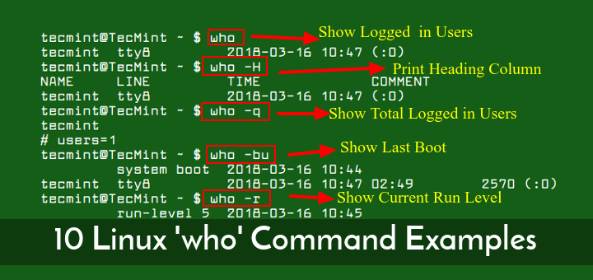

**what is the diff b/w redhat and ubuntu?**

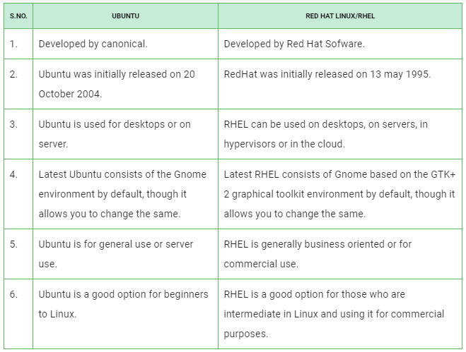

**How to create multiple directories in one shot? ---**mkdir -p

**How to give previous output as the input in Linux?—**Using pipe operator

**Use of wget command?**

It’s a command-line utility tool used to download files from the internet

**How to change the permissons for file?--**chmod

**In vim editor how to delete nth line?---using n**dd (where n is the no of line)

**What is the use of top command?—**

top command is used to show the Linux processes. It provides a dynamic real-time view of the running system

**How to check the ram usage?--** free command

**How you check the disk usage?—**df -h command

**What is the difference between awk and grep?**

grep is to find lines or files containing text matching,whereas

awk command searches files for text containing a pattern. When a line or text matches, awk performs a specific action on that line/text and also using awk we can filter particular coloumn